Pollinator Scavenger Hunt
Contest Entry Form
Submit your entry by September 1, 2019
A good scavenger is sharp-eyed and clever at catching things. In this contest, you’ll be catching bugs digitally. Each

And a photo of a flower they planted for a pollinator and

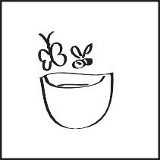
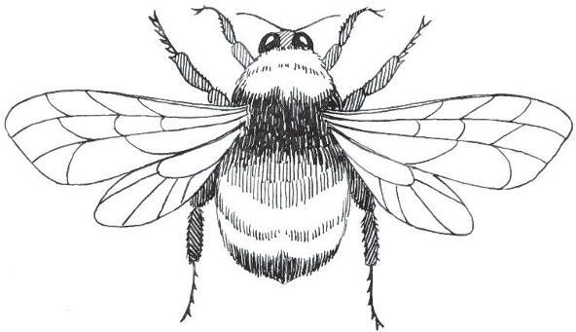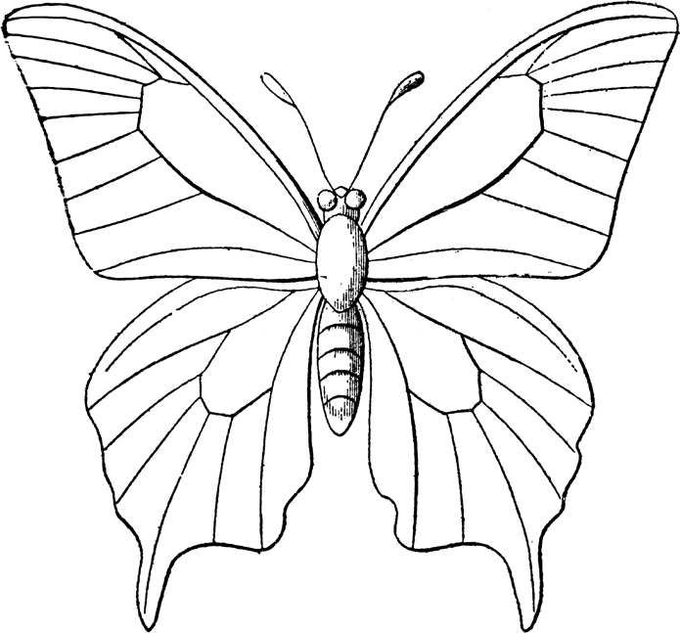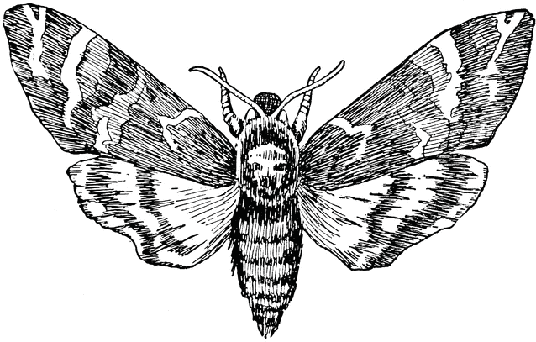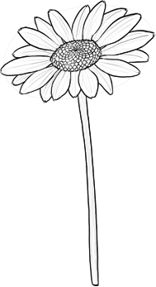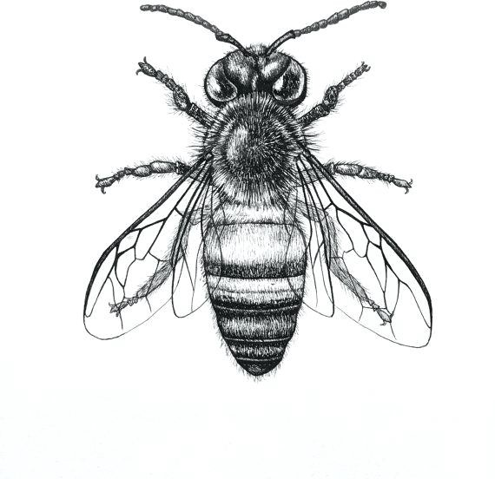contestant must get a photo of each of the four insects below: a bee or butterfly bath they made.

Different Bee
Bumblebee Butterfly Moth Plant a flower Make a bee bath
To be eligible for this contest, you must be a student in grades K-5 attending public, private or home school in of either the Lake Oswego or West Linn/Willsonville school districts.

Your School Name:
To enter the drawing for prizes, please attach this form and the 6 photos of what you found on your scavenger hunt and email it all to B4theBees@gmail.com.

Scavenger’s Name

Parent or guardian’s info Name

email
Phone
Prefer? text email

Contest Rules
One entry per person, must be received by September 1, 2019.
No purchase necessary to enter or win. All applicants must be K-5 and attend school in the districts listed above. One family can have multiple entries, but only one entry per person. There will be a random drawing for the prizes by Sept 7th and winners will be notified by text or email. Prizes can be picked up at our booth at the Stafford Hamlet Family Fest on Sept 14th @ Fiala Farms, 21231 Johnson Rd, West Linn OR 11am - 4 pm. Entry and parking at this event is free. If you can’t attend arrangements for prize pickup will be made.
This contest is sponsored by Plant4Pollinators, an independent group working to raise awareness of what we need to do to help our bees and butterflies.
No names or contact information will be collected, held or sold in any way unless you opt in for an email announcing next year’s contest when we send out your Jr. Entomologist Certificate.
Thank you for making a positive addition to the habitat for our bees and butterflies!
Because of actions like yours, more healthy pollinators will move into your neighborhood.
The prize drawing will be done on Sept 7th. You’ll receive a text or email if your name was drawn!
Any questions? Find insect hunting tips and contest FAQ at www.plant4pollinators.com contact person: Carol Yamada B4thebees@gmail.com

